https://doi.org/10.53656/math2025-?-?-add | For editorial use. Do not edit  here or the link in the left
A TEMPLATE FOR THE JOURNAL MATHEMATICS AND INFORMATICS
Neno Borisov¹⁾, Krum Modev²⁾
¹⁾Institute of Mathematics and Informatics, BAS, Sofia (Bulgaria)
²⁾Journal “Mathematics and Informatics”, Sofia (Bulgaria)
Abstract. This template is dedicated to the authors that would like to submit papers for publishing in the Journal “Mathematics and Informatics” and will prepare their works with some version of the program MS Word (or LibreOffice). Instructions for the authors that will prepare their work with LATEX or some WYSIWYG (What You See Is What You Get) editor are subject of another template.
Keywords: template; paper formatting; MS Word; LibreOffice
- Introduction
In order to make the process of editing and issuing the booklets of the Bulgarian Journal of Educational Research and Practice “Mathematics and Informatics” more efficient, the authors, when are preparing their paper, have to follow strictly this template. It is dedicated for authors that are preparing their articles with MS Word (or LibreOffice).
The main formatting rules are concerning the kind, the size and the style of the used fonts in the different parts of the article, intervals between lines and paragraphs, indentations of the beginnings of the different paragraphs, and so on.
- Formatting the head of the article
  - Formatting the title
The title of the paper has to be written in capital letters in the language of the paper – English or Bulgarian. The Font for the whole paper has to be Computer Modern Serif (CMU), the Size – 14pt, center alignment and bold. The Spacing has to be 18pt before the title and 12pt after the title. Furthermore, for most paragraphs in the paper the before and after Spacing should be 0pt everywhere and the Line Spacing for all paragraphs of the paper have to be Single.
2.2. Formatting the list of authors
The information about the author(s), must be aligned Right. For each author, the scientific title (if any), the scientific degree (if any), the name and the surname must be written. The Font Size has to be 11pt, and the Font Style must be Bold. If the paper has more than one author, the names have to be separated by commas. A superscripted index is added to note the authors affiliation.
2.3. Formatting affiliation of authors
The paragraphs for the affiliation(s) of the author(s) includes the name of the institution, the city (only for clarity when the city is not included as a part of the name of the institution) and the country in brackets. If the author(s) have different affiliations, then you must add a separate line for each of them. When different authors have the same affiliation, do not repeat it – make them use the same index instead. When more than one affiliation is needed, they have to be enumerated with consecutive numbers started from 1, placed in front of the name of the affiliation, separated from the name by right bracket and formatted as superscripts. In such case the number of the affiliation of each author has to be placed (also as superscript) in front of her/his titles and names. The Font Size must be 9pt, the Alignment – Right, and the Font style – Italic.
2.4. Abstract and Keywords
The paragraphs for the Abstract and the Keywords must be formatted with Font Size 10pt, Justified Alignment. The Abstract is with Regular font and the Keywords are Italic. The word Abstract must be in Bold. Both paragraphs must have first line indentation of 0.2" and paragraph indentation 0.2". The Keywords are separated with semicolons and are lowercase (except when they are names). The last keyword does not have a semicolon at the end. The Paragraph Spacing before the Abstract and after the Keywords has to be 12pt. The keywords must cover the topic of the paper. Do not include more than 10 keywords.
- Formatting the sections of the paper
The text of the paper should be composed of few sections. A common pattern includes: Introduction (describes the goals of the paper, the place of the research in the status quo of the domain, stressing the main moments of the work and so on); Context of the paper (most important result of the author(s) and/or other researchers that preceded the work or the work use them); Scientific apparatus used in the work (definitions, theorems, methods, algorithms, software, environments, materials, methods and so on); At least one section describing the Obtained results; Conclusions; and Future works.
Each section title of the paper has to start with a numbered title, formatted with Font Size 12pt, Bold, Indentation Left 0.2", Special Hanging 0.2", Spacing Before 12pt and Spacing After 0pt. The Paragraphs of the section have to be formatted with Font Size 11pt, Regular, First Line indentation 0.2", Right Indentation 0.02", Spacing Before and After 0pt, Single Line Spacing.
One level of subsections is accepted and, if any, the subtitle of them must be with Font Size 11pt, Bold + Italic, Space Before 6pt and Space After 0pt.
- Figures and tables
Figures that have surrounding text must be placed inside text boxes without shape outline. Their Caption must be with Font Size 11pt, Centered, line spacings Before – 6pt and After – 0pt. The text Figure, its consecutive number and dot sigh have to be in Bold and separated from the caption with an interval. The font style of the caption must be Regular. An example is shown on fig. 1.
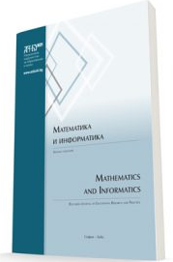
Figure 1. The
journal cover page
Larger figures without surrounding text are placed on separate paragraph. It is recommended that they fit the width of the paragraph. The paragraph itself has no First line, Left or Right indentations. An example is shown on fig. 2.
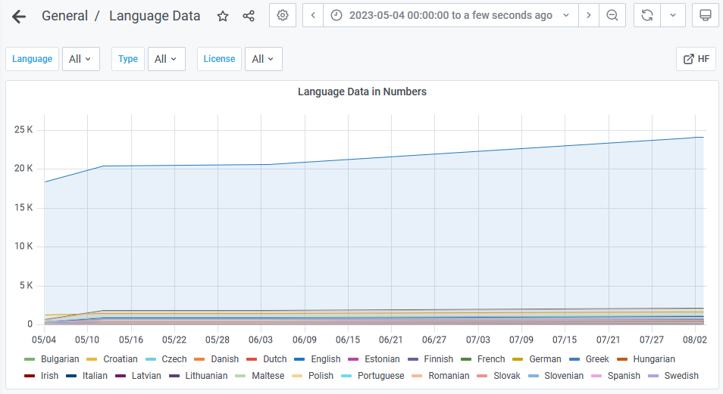
Figure 2. Main window of an application
The text and the images in the figures must be large enough to be readable on a printed paper. The example on fig. 2 shows the smallest possible font which can be printed well enough. Usually you should look for a larger font in your figures.
Always refer to the figure with its number in the text and try to place it as close as possible to the reference. Do not refer to the figure with words like “as shown on the figure below/above”.
Table captions must be formatted like the figure’s captions; however, it must be placed above the table. The referring is also the same (see the example in table 1). :
- Make zero indentation of all cell paragraphs;
- Replace texts which are repeated in many cells with appropriate abbreviations. An example is shown as a note below table 1;
- When the table includes a lot of data, you may use a smaller font size – like 10pt or even 9pt. Do not make it smaller than 9pt, because this will make the text unreadable after printing the paper;
- Use the full width of the page;
- Center the column titles;
- Use Bold style for column and row titles.
Table 1. Sample for formatting a table
Finalist Indicators | ASCON |  |  | Elephant
AEAD | Yes |  |  | Yes
Varieties | AS-128 | AS-128a | AS-80pq | Dumbo | Jumbo | Delirium
Level of security [bits] | 128 | 128 | 128 | 112 | 127 | 127
Key size [bits] | 128 | 128 | 160 | 128 | 128 | 128
Unique number (Nonce) [bits] | 128 | 128 | 128 | 96 | 96 | 96
Tag [bits] | 128 | 128 | 128 | 64 | 64 | 128
Building block | AS Permutation |  |  | Spongent-π[160] | Spongent-π[176] | KECCAK – f [200]
Mode of operation | Duplex |  |  | Encrypt-then-MAC
Note: AS stand for ASCON.
- Mathematical expressions
Mathematical expressions have to be formatted with the standard Equation Editor. Do not use third-party addons and special tools for editing the formulas. Short expressions like $ax^{2}+bx+c=0$ can be placed Inline with the text. Larger expressions should be placed centered in a separate paragraph, as shown in the following example:
$$f\left(x\right)=a_{0}+\sum_{n=1}^{∞}{\left(a_{n}cos\frac{nπx}{L}+b_{n}sin\frac{nπx}{L}\right)}.$$
For large expressions use 6pt spacing Before and After the paragraph. If you need to enumerate the mathematical expressions, place the corresponding numbers in brackets in right of the formula.
- Notes and References
Every non-scientific reference should be placed in a special unnumbered section named Notes before the scientific References. For example, notes can include comments¹, URL addresses of Web pages², published in internet institutional or corporative materials that have no authors³, and others. All notes are formatted in numbered list. The references to them are indicated as superscripts at the appropriate place in the text.
The scientific references are included in an unnumbered section References. It should be formatted following the standard ISO 690-2021 (a.k.a Harward Standard). Detailed presentation and examples can be found on the journal website². Briefly the author names are written with capital letters, followed by the year of publishing and the journal or conference proceedings where it is published. All sources must be written in Latin letters. If the source is from another language, it must be translated to English or transliterated. In such case the language of the source has to be mentioned in brackets, followed by the original reference of the source. Referenced sources have to be sorted lexicographically by the author(s) name(s).
Every source from the references and notes must be referred somewhere in the text. The sample sources from this template can be referenced like: (Borisov, 2020; Leontiev & Tihonova, 2023; Tihonova et al., 2016). If you directly quote text from specific reference, make it in italic style.
- Final maters
The end of the paper you must include a list with the authors. The titles and the name of the author should be Font Size 11pt, Bold, Space Before 12pt, Space After 0pt. Contact details follows with Font Size 9pt., Regular, Space Before and Space After 0pt. Please include researcher IDs (ORCID, WoS research ID, etc.); affiliation; physical address and e-mail address.
Acknowledgments
All acknowledgments have to be placed in an unnumbered section after the last section of the paper. The Editorial board of Scientific Journal Mathematics and Informatics will be very thankful to authors of submitted articles, which followed strictly the formatting described above.
NOTES
- This is an example sideway note.
- Journal Mathematics and Informatics, Guidelines for authors: https://mathinfo.azbuki.bg/en/mathinfo/za-avtorite/
- Ministry of Education and Science of Bulgaria, Pre-school and School Education Act (in Bulgarian, Министерство на образованието и науката, закон за предучилищното и училищното образование).
REFERENCES
Borisov, N. (2020). On a problem from SMC. Matematicheskiy Jurnal, 60(2), 30 – 33. [in Russian, Борисов, Н. (2020). Об одной задаче состезания ССМ. Математический журнал, 60(2), 30 – 33].
Leontiev, K. & Tihonova, P. (2023). Intro to Competitive Programming. Nauka. [in Russian, Леонтиев, К., Тихонова, П. (2023). Введение в олимпиадное программирование. Наука.].
Tihonova, P., Leontiev, K. & Kirov, A. (2016). Reconstruction of Trees Using Metric Properties. Olympiads in Informatics, 7, 80 – 92.

 Prof. Neno Borisov, DSc.
ORCID iD: 1000-0003-0162-2701
Institute of Mathematics and Informatics,
Bulgarian Academy of Science,
Sofia, Bulgaria
e-mail: borisovn@math.bas.bg
 Dr. Krum Modev
ORCID iD: 1000-0001-1172-4731
Journal “Mathematics and Informatics”,
Sofia (Bulgaria)
e-mail: krmdv@azbuki.bg

